**Design Document:**

**Vingers Food Restaurant**

| **Supervisor.** | **Sir Ebad Uddin** | |
| --- | --- | --- |
| **Batch.** | **2210C2** | |
| **Group.** | A | |
| **Serial No.** | **Enrollment Number** | **Student Name** |
| 1. | 1424655 | Abdur Raffay Sheikh |
| 2. | 1424363 | Sadia Bader |
| 3. | 1423495 | Wajiha Khadim Hussain |

Acknowledgement

First and foremost, I would like to express my gratitude to my esteemed teacher who provided invaluable assistance in reviewing this project within the stipulated time frame.

I would also like to extend my sincere appreciation to the eProject team at Aptech Head Office, who graciously granted us the opportunity to undertake this exceptional project on Durable Furniture.

Furthermore, we are extremely grateful to the eProject team, whose support has yielded numerous benefits, including the reinforcement of our skills through the experiential learning process, and the guidance of a mentor to prevent us from losing focus.

Undoubtedly, working on this project has instilled in us a great deal of confidence, enabling us to articulate our thoughts effectively during interviews. We have gained extensive knowledge and expertise on the subject, which will undoubtedly be invaluable in our future pursuits.

Synopsis

Our restaurant has made it easy for people to discover and explore our delicious cuisine through our website. Visitors can view images of our seating arrangements and decor, as well as learn about our signature dish, the "relaxing platter." We offer a subscription service to notify customers of new dishes and specials. Visit our website to view our menu, make reservations, and experience our exceptional dining.

In addition to our mouth-watering signature dishes, we take great pride in providing exceptional customer service and a welcoming atmosphere.

Problem Definition

Vinegar Food Restaurant which is the flagship brand of JADONS Ltd has spread its aroma in this industry over the past few decades. Known as “the Serving plates” with 72 different rotating menus and 240000 delicacies throughout the country.

The organization wants a website to be made which should spread the aroma online. The main Highlights of the restaurant must be highlighted in the website. The restaurant has more than 1000 branches till date.

Customer Requirement Specification (CSR):

The Web site is to be created based on the following requirements.

1) Home page must add header section with an image which would show

different range of dishes images.

2) The menu list must be added in one section of the website

3) The bottom navigation panel must be designed.

4) Navigation of the website must be made user friendly.

5) Links such as

1. Home
2. About us
3. Meals
   1. i. Regular
   2. ii. Lunch
   3. iii. Snacks
   4. iv. Desert
   5. v. Beverages
4. Gallery
5. Awards
6. Catering
7. Recipe of the month
8. Contact us
9. Feedback (can add query, suggestion or complaints)

6) You can add additional links as well as modify but make sure all the type of

food must be included.

7) Look and feel must be made user friendly.

8) Uniformity and Navigation must be made smooth throughout the website.

9) Site map, Gallery, about us, Queries link, Contact us link must be added.

Scope Of the Work:

We have chosen to develop our website for the Windows platform using HTML5, JavaScript, and Bootstrap jQuery. Our website is designed to function smoothly in all major browsers, including Chrome, Firefox, and others.

When users land on our welcome page, they will be automatically redirected to the main web page, where they can easily navigate to the relevant content they are looking for. We understand the importance of providing a seamless user experience, and we have taken great care to ensure that our website is user-friendly and easily accessible.

We believe that our website will serve as the perfect platform to showcase our products and services to our valued customers, and we look forward to their feedback and input.

Aggregated Sitemap:

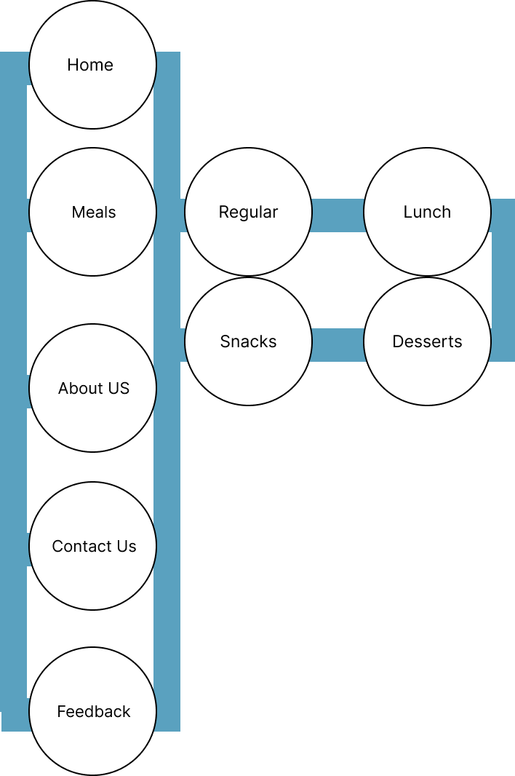

Wire Frames:

**Home Page:**

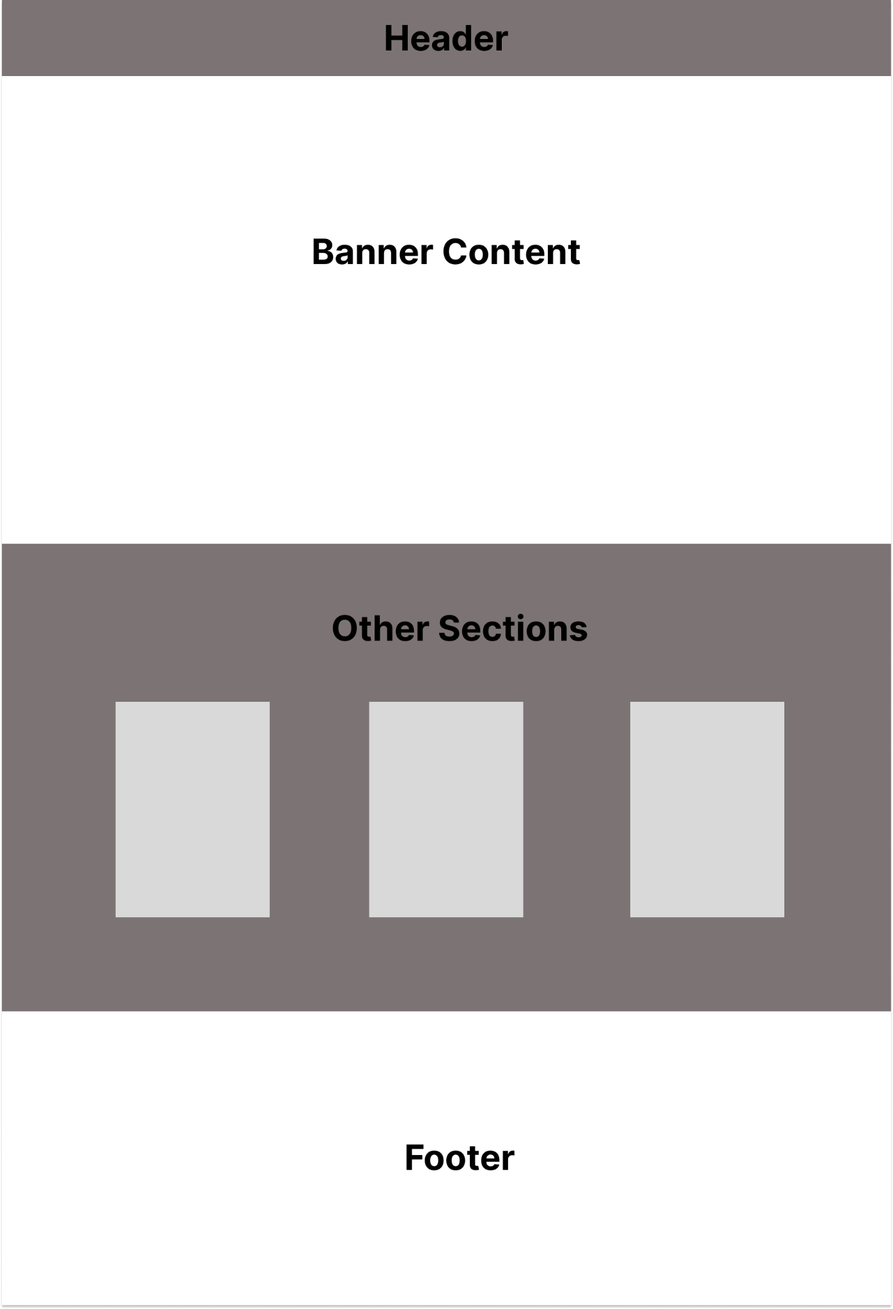

**Other Pages:**

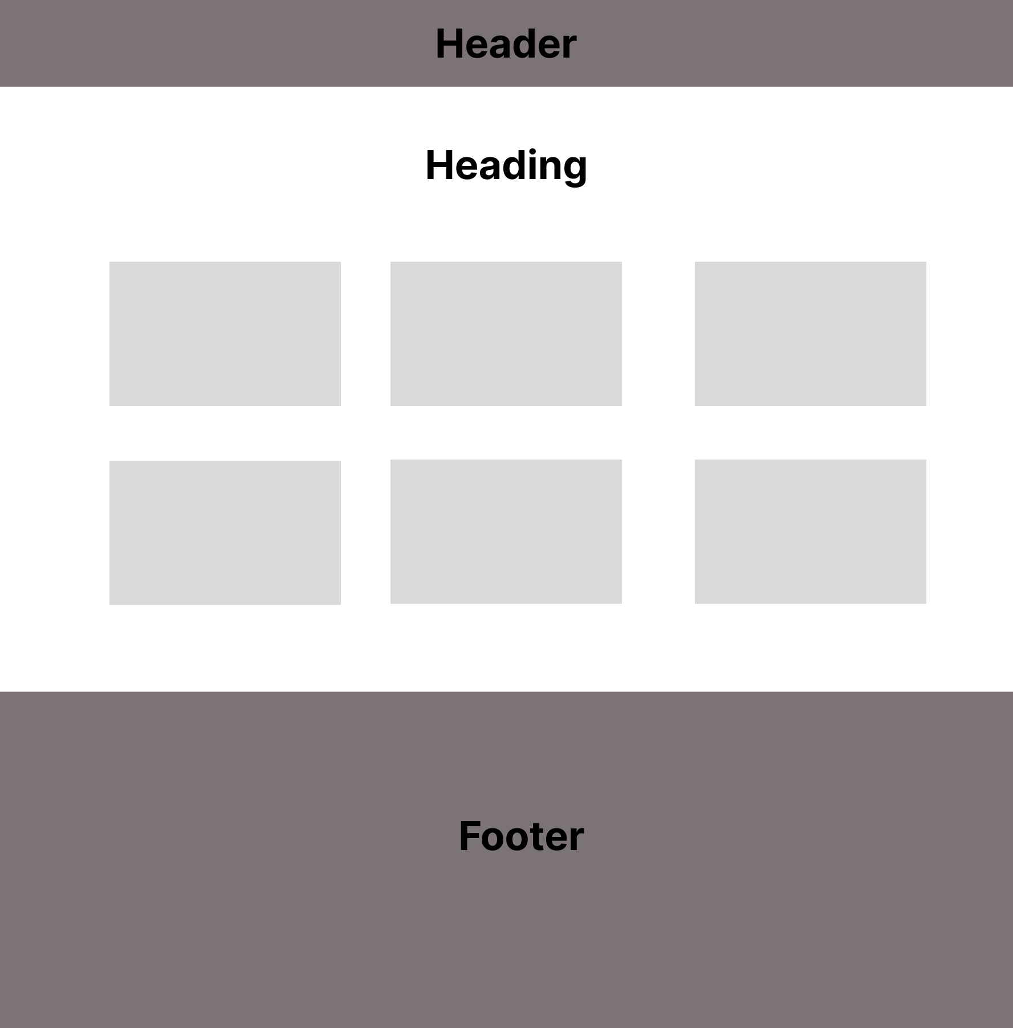

**Contact/Feedback:**

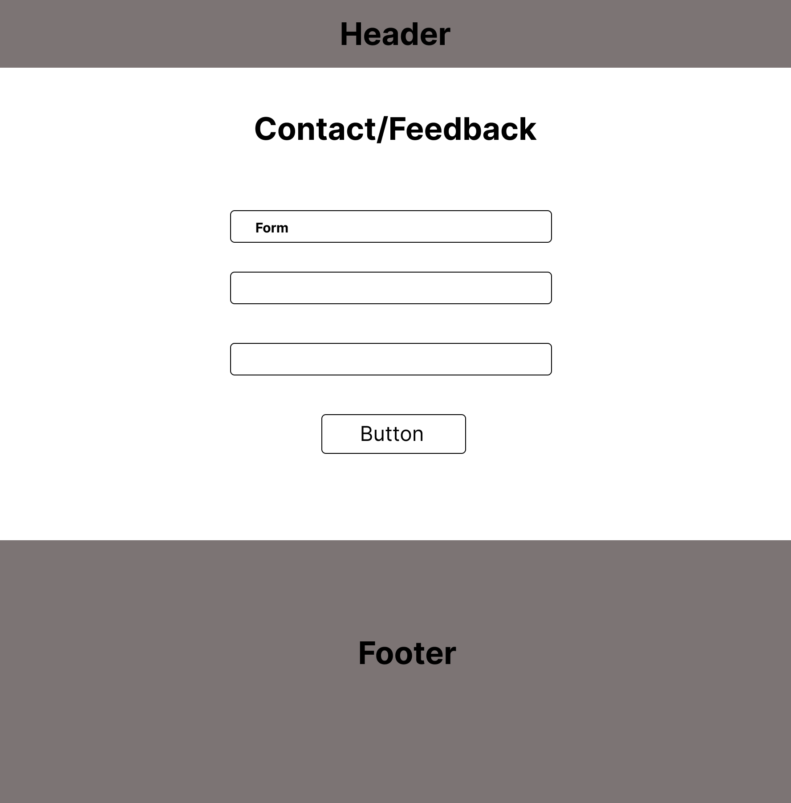

Task Sheet:

| **Name:** Vinegar Food Restaurant | | Date of Preparation of Activity Plan | | |
| --- | --- | --- | --- | --- |
| No | Task | Actual | Teammate | Status |
| Start Date | Names |
| 1 | Gather Assets | 24-feb | Raffay | Complete |
| 2 | Build Home-banner | 25-feb | Raffay | Complete |
| 3 | Modify Header | 25-feb | Raffay | Complete |
| 4 | Build Footer | 26-feb | Raffay | Complete |
| 5 | Add other sections to Home Page | 28-feb | Raffay | Complete |
| 6 | Build Other Pages:  About Us/Meals-main/Catering/Gallery/Awards | 29-Feb-15-March | Raffay & Sadia | Complete |
| 7 | Build Meals-subpages and Recipe of the month Page | 16-march | Raffay | Complete |
| 8 | Contact Us/ Feedback | 17-march | Raffay & Sadia | Compete |
| 9 | Making Everything Responsive | 18-march | Raffay | Complete |
| 10 | Using Jquery to add Background Switcher for Home Page | 19-march | Raffay | Complete |
| 11 | Using AOS animation to add animation | 20-march | Raffay & Sadia | Complete |
| 12 | Solving Responsive Issues | 21-march | Raffay & Sadia | Complete |
| 13 | Making Presentation and Supporting Documents | 22-march-24-march | Raffay & Sadia | Complete |
| 14 | Checking Colors, Browser Support and making sure everything is as required | 24-March-  25 March | Raffay & Sadia | Complete |